**Assignment MT1-2021_2**

**Section 1**

**From book: Principle of Mass Transfer by B.K.Dutta**

**Ex.3.1 Page no.79**



**Ex.3.2 Page no.80**

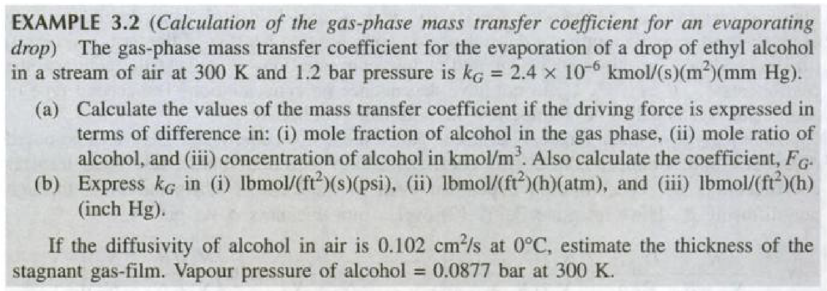

**Ex.3.3 Page no.87**

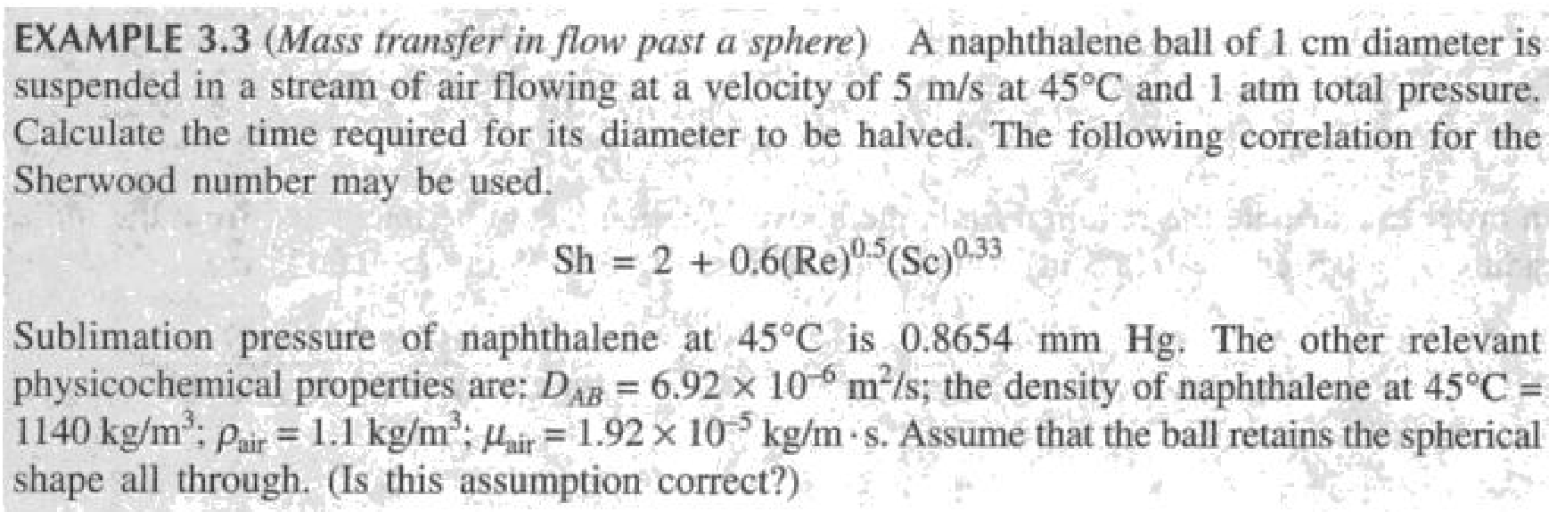

**Ex.3.4 Page no.89**

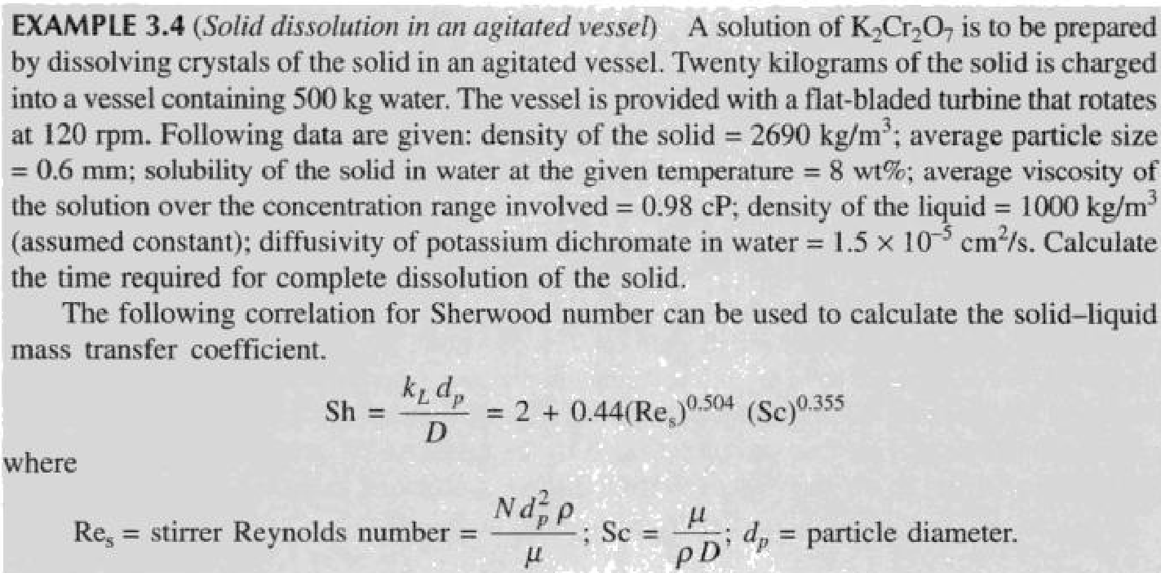

**Ex.3.5 Page no.99**

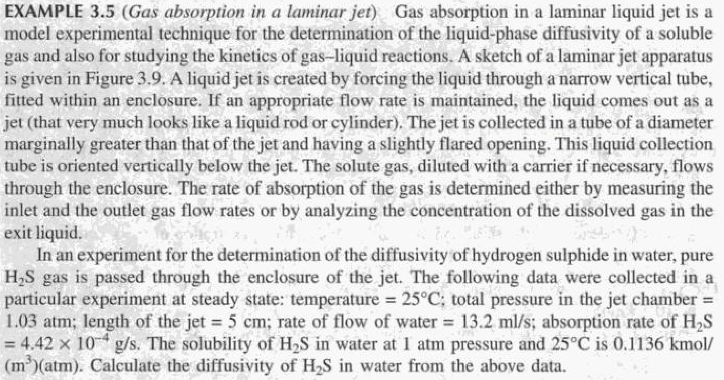

**Ex.3.6 Page no.100**

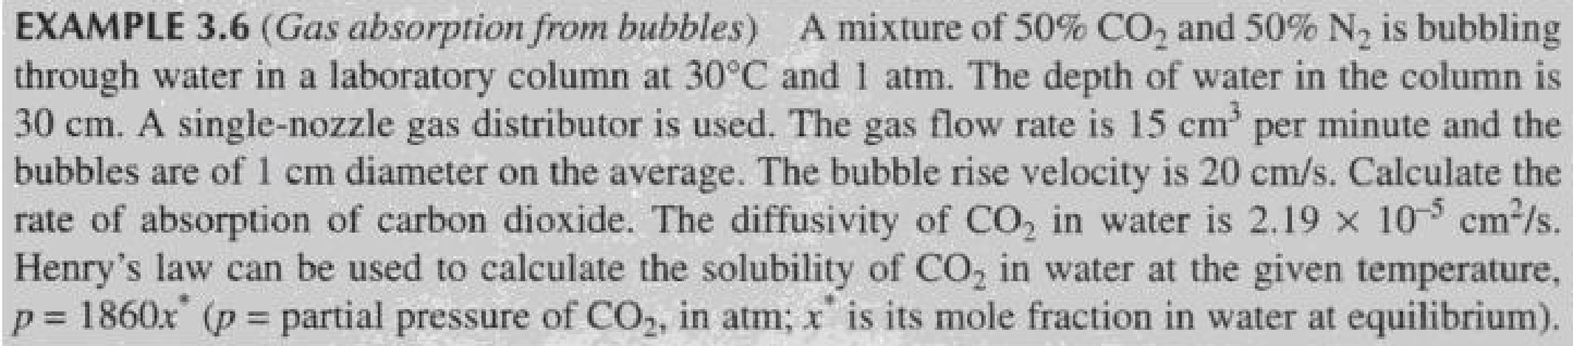

**Ex.3.7 Page no.101**

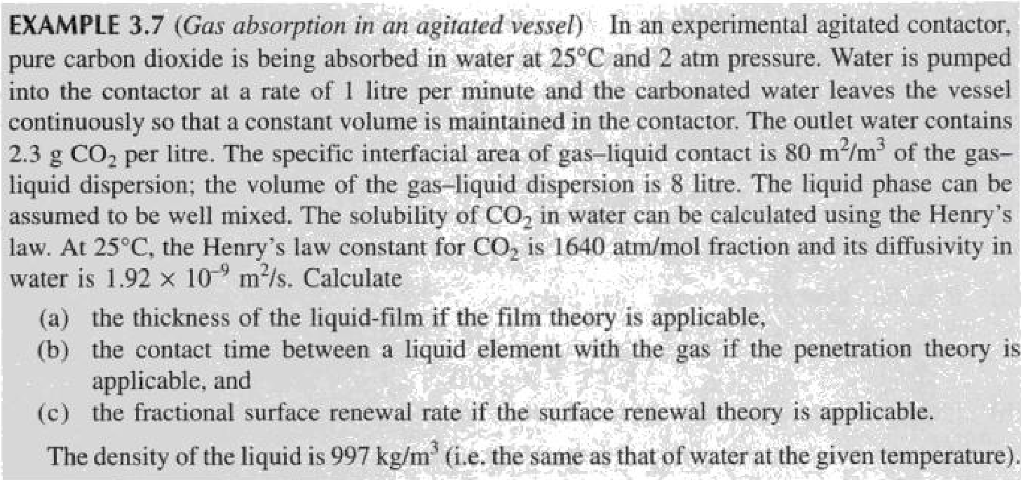

**Ex.3.8 Page no.104**

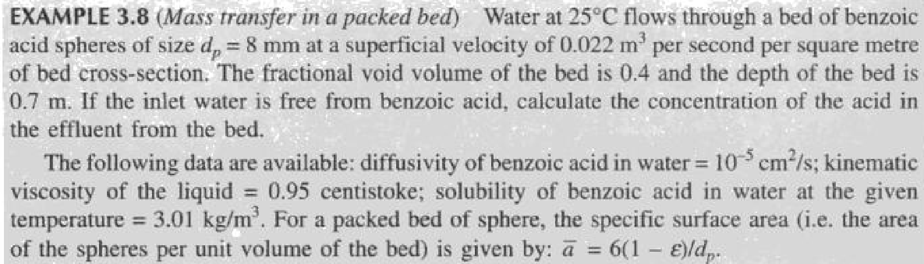

**Ex.3.9 Page no.105**

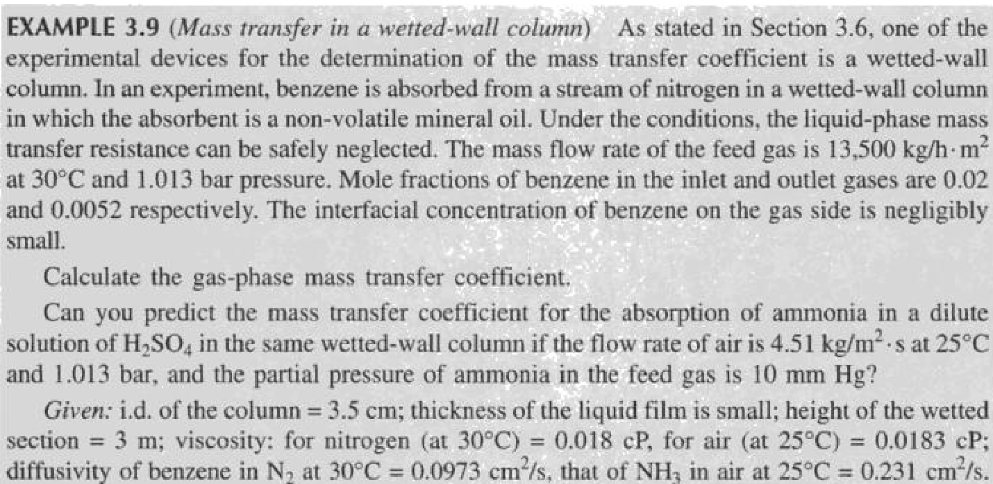

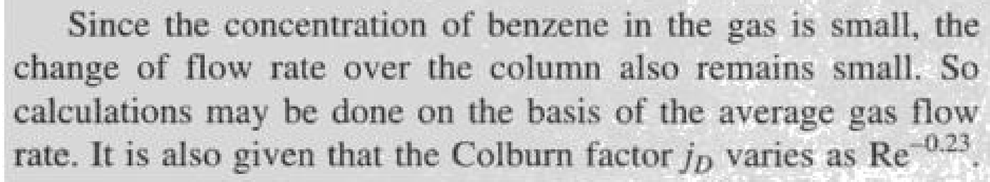

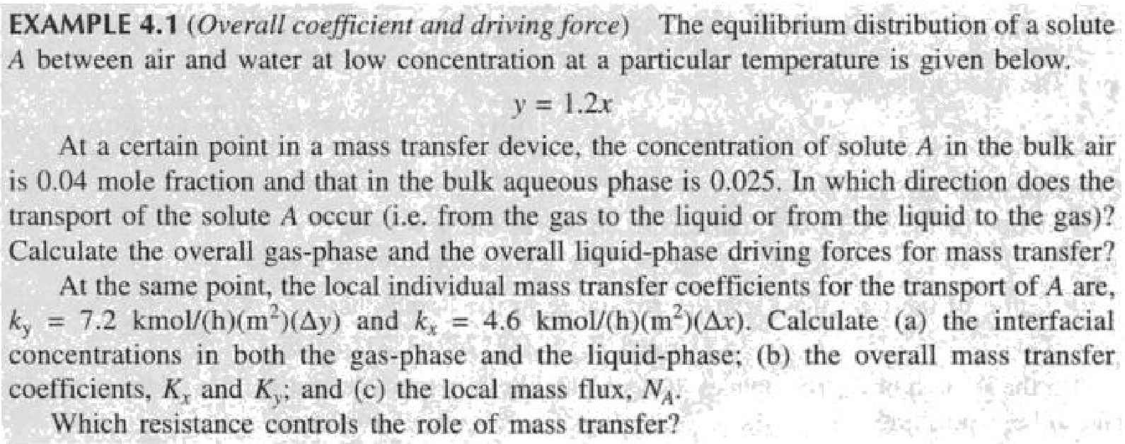

**2.2)** Example 4.2 page no-134

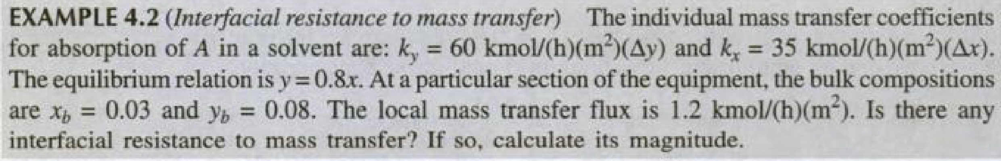

**2.3)** Example 4.3 page no-134

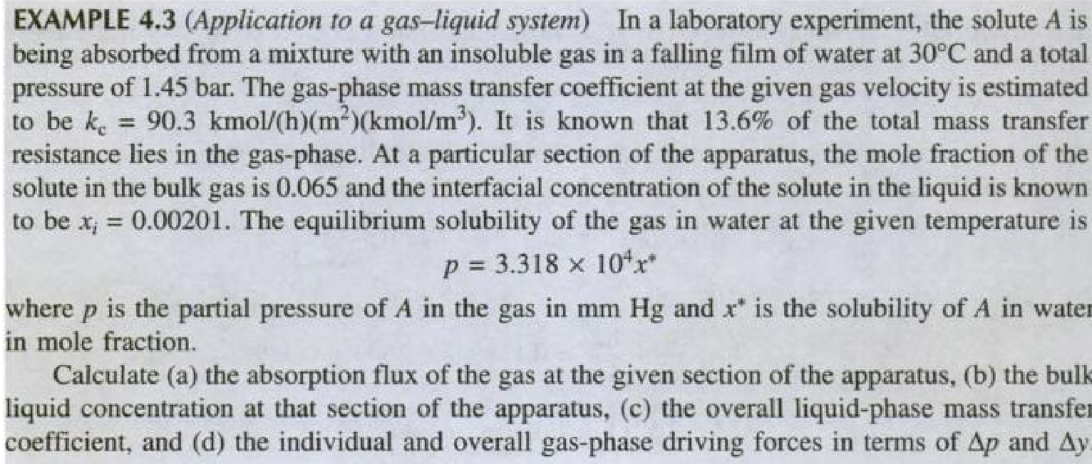

**2.4)** Example 4.4 page no-136

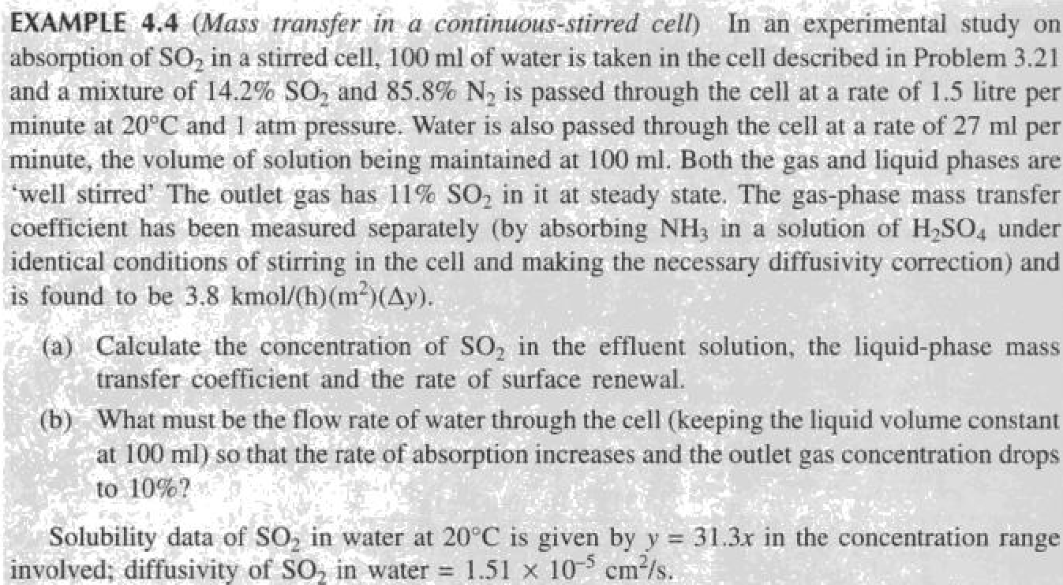

**2.5)** Example 4.5 page no-137

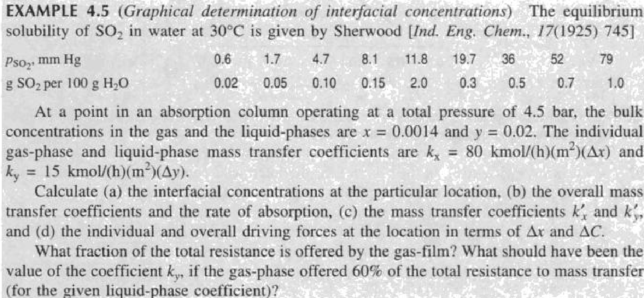

**2.6)** Example 4.6 page no-148

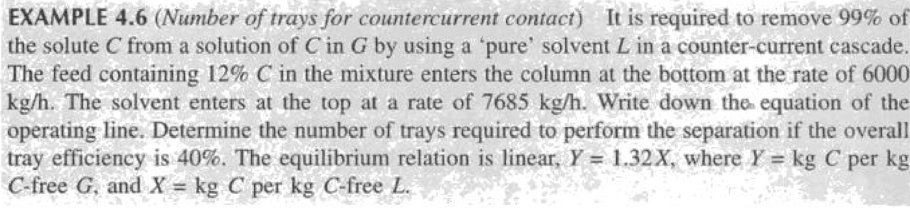

**2.7)** Example 4.7 page no-151

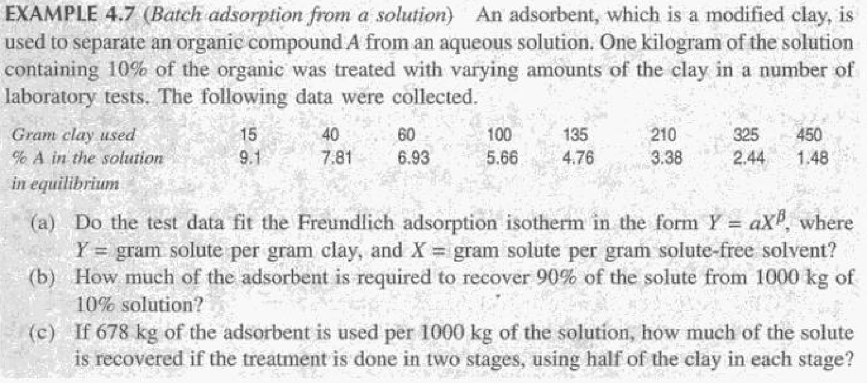

**Section 2**

**Unsolved Problems**

**2.1)**A stream of air at 100 kPa pressure and 300 K is flowing on the top surface of a thin flat sheet of solid naphthalene of length 0.2 m with a velocity of 20 m/sec. The other data are:

Mass diffusivity of naphthalene vapor in air = 6 * 10–6 m 2/sec

Kinematic viscosity of air = 1.5 * 10–5 m 2.sc

Concentration of naphthalene at the air-solid naphthalene interface =1 * 10–5 kmol/m3

Calculate:

1. the overage mass transfer coefficient over the flat plate
2. the rate of loss of naphthalene from the surface per unit width

Note: For heat transfer over a flat plate, convective heat transfer coefficient for laminar flow can be calculated by the equation.



you may use analogy between mass and heat transfer

**2.2)** 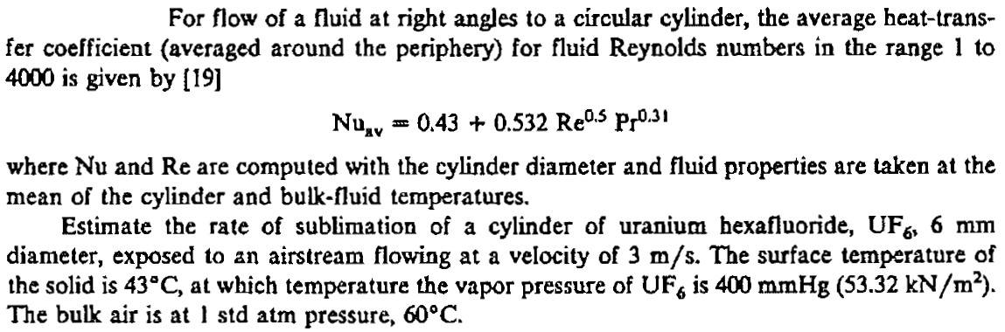

2**.3)** A solid disc of benzoic acid 3 cm in diameter is spin at 20 rpm and 25°C. Calculate the rate of dissolution in a large volume of water. Diffusivity of benzoic acid in water is 1.0 * 10–5 cm2/sec, and solubility is 0.003 g/cc. The following mass transfer correlation is applicable:

Sh = 0.62 Re ½  Sc 1/3

Where  and ω is the angular speed in radians/time.

**2.4)** Determine the Schmidt number for methanol in air at 298 K and 1.013 *105 Pa and in liquid water at 298 K.

**2.5)** Dittus and Boelter proposed the following equation for correlating the heat-transfer coefficient for turbulent flow in a pipe



What should be the corresponding equation for the mass-transfer coefficient when the transfer is to a turbulent fluid flowing in a pipe?

2.6

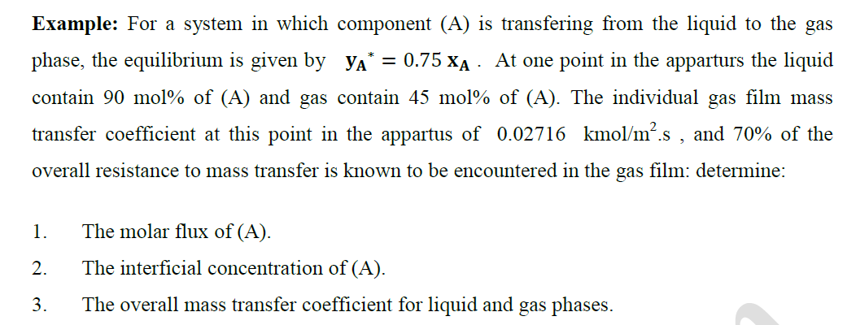

2.7)

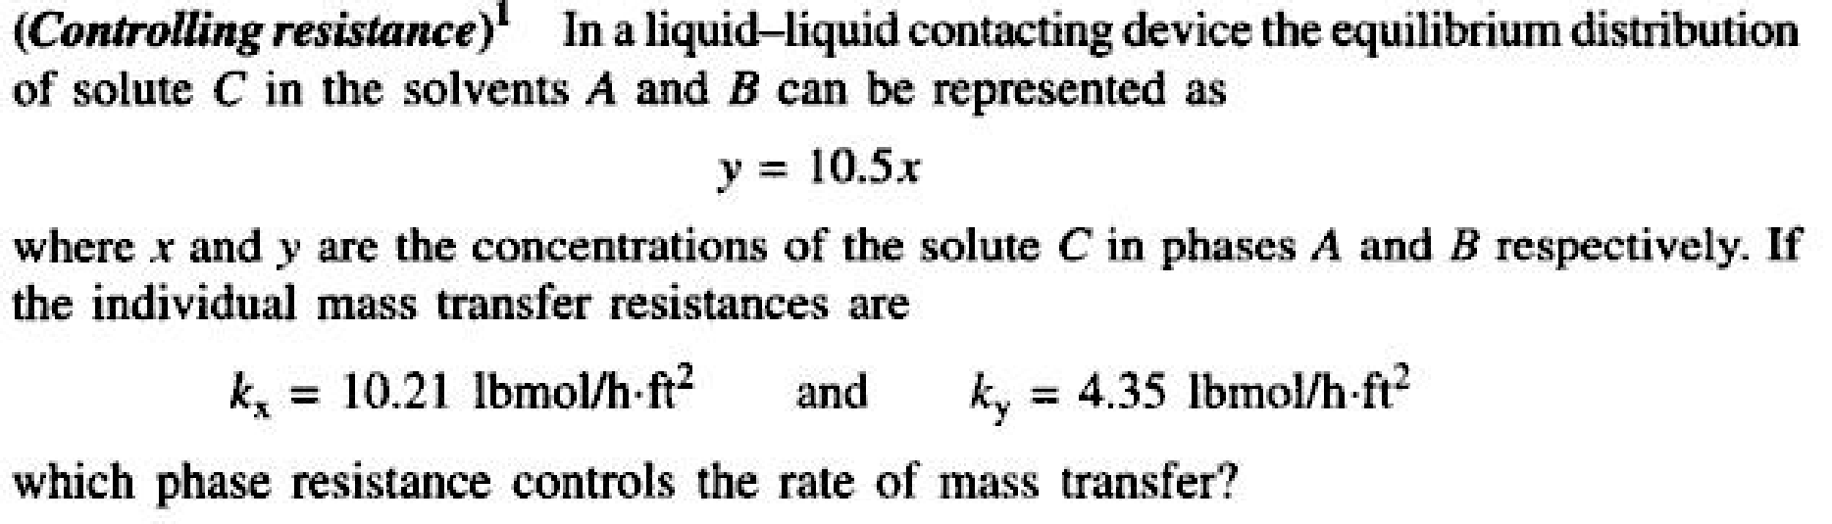

**2.8)**

**In an experimental study of the absorption of ammonia by water in a wetted-wall column, the value of overall mass transfer coefficient, KG was found to be 2.75 10-6 kmol/m2 -s-kPa. At one point in the column, the composition of the gas and liquid phases were 8.0 and 0.115 mole% NH3, respectively. The temperature was 300K and the total pressure was 1 atm. Eighty five % of the total resistance to mass transfer was found to be in the gas phase. At 300 K, Ammonia –water solutions follows Henry’s law upto 5 mole% ammonia in the liquid, with m = 1.64 when the total pressure is 1 atm. Calculate the individual film coefficients and the interfacial concentrations. Interfacial concentrations lie on the equilibrium line.**